Querquedule!
You are a cyberteal on a mission to clear a plague of locusts and prevent the rise of the Querquedule Technocracy.

Parts Needed
- 12 Round Discs (dimes work well)
- 1 Player Token
- At least 3 regular dice
- Printed copy of the map
- Pencil

Object
The object of the game is to clear the map of locusts with 15 moves or less. You have various anatine and cybertech special abilities at your disposal to help you in your mission.

Setup
Creating your Teal: You have two abilities, Querquedule and Cybertech. Roll one die for each stat to determine your score for each one.
Example: Rolling a 4 and a 5, the player decides to make 4 the Querquedule stat and 5 the Cybertech stat.
Placing the Locusts: Roll six regular dice and place one die next to each row of the map. No die can be next to another die of the same value. If four or more dice have the same value, re-roll them all. Place a disc token in the column that matches the number on the die for each row.
Re-roll the six dice and place one next to each row of the map. Again, two dice with the same value cannot be next to each other. If a die would cause a locust token to be stacked on another, re-roll that individual die. As long as the result is different from the previous roll, place the token in the column that matches the value of the rerolled die. This is true even if the roll results in a value that is same to another die above and/or below it.

Locust Placement Example
Rolling six dice provides these results:


Seeing that one or more dice must be placed between the 1's. The player arranges their dice like this and places tokens accordingly:
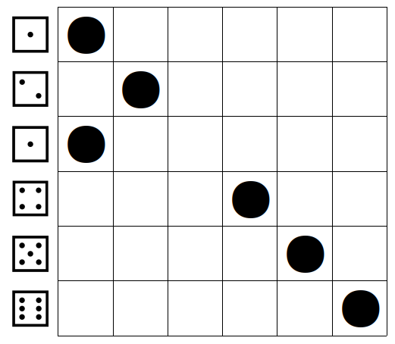

The next roll of six dice produces this result:



A four cannot be placed in the fourth row because the token would be placed on top of a token already placed on the board. The same is true for one of the rolled fives on the fifth row.
Being careful to avoid placing a four next to another four or placing the fives next to each other, the player arranges their dice and places the tokens as follows. The second placement is shown in blue for clarity.

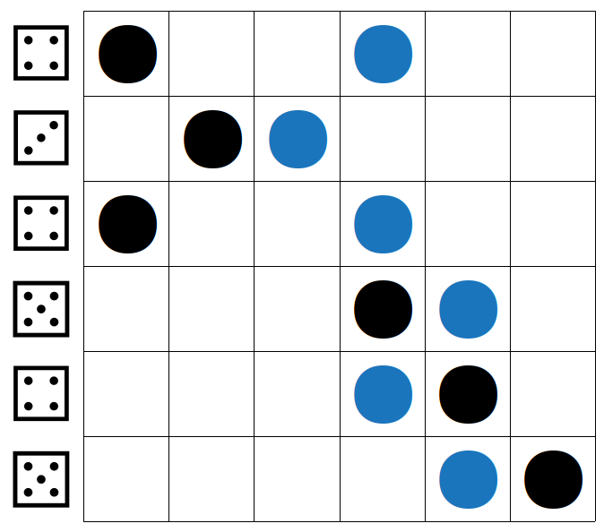

Placing your Teal:
Roll two dice to place your teal at a starting point. One die represents the row number, the other represents to column number. You may order the dice as you like.
Example: Rolling a 2 and a 4, you may place your teal in the second row on the fourth column or the fourth row in the second column. In this example, the player chooses Row 2, Column 4. (Shown in dark teal below)

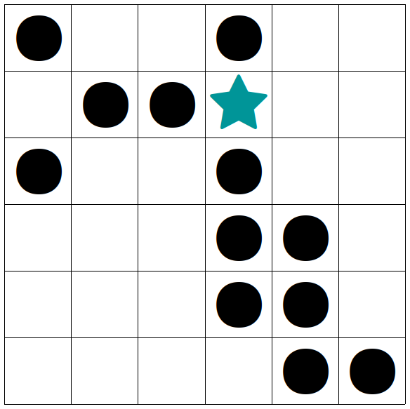

Special Abilities

Querquedule Abilities

The Great and Terrible Quack
This will force all adjacent locust swarms to stack on an adjacent locust swarm.

Feast of the Conscripts
Ducks from other flocks are summoned to feast on an adjacent locust swarm.

Cybertech abilities

Bionic Speed
You may take a free move without cost.

Called Strike
Clear locusts on any one square on the grid.

Play
- Moving your teal one space in any direction costs a turn
- Clearing the space you occupy of locusts costs nothing.
- Using a Special Ability costs one point of the other stat per attempt.

Using a Special Ability
To use a special ability, roll both dice and add the applicable stat. If the total is seven or greater, the special ability is successful. Regardless of success, the attempt will cost one point of the other stat.
Example: Using the Cybertech Called Strike ability requires a roll of both dice. The sum of the roll plus the Cybertech stat must be seven or more to succeed. If successful, the token or tokens in the indicated square are removed. The player then deducts 1 from the Querquedule stat.

Example of Play
The cyberteal in this game has a Querquedule stat of 4 and a Cybertech stat of 5.
For the first action, the player attempts the Great and Terrible Quack special ability to stack the adjacent tokens on the third row. Since it is a Querquedule special ability, the players rolls both dice and adds four to the result of the roll. Rolling 5 and adding 4 equals 9, a success! The locust swarm tokens are stacked in the third row.

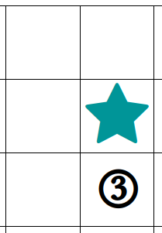

As another action, the cyberteal is moved to cover the stack of tokens in the third row. The player will place a tick mark in the Turns box. Remember that moving the cyberteal is the only action that costs a move.

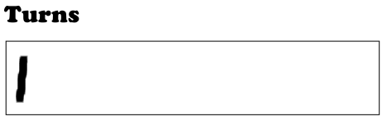
For the next action, the cyberteal clears the sqaure of locust swarms. The player removes the tokens and sets them aside.
The Locust Map Grid now looks like this as the player considers their next action:
